Regular Monthly Meeting
Beaverhead Trails Coalition
January 18th, 2018

Present: Craig Simonsen, Pamela Laursen, Bill Laursen, Pat Carrick, Matt Walter (USFS), Dan Downey, Betty Mooney, Joyce Connors, Michael E. Mhoon, Eric Wendland, Cliff Stout, Sara Maslen, Larry Volkening (Bike Walk Montana), Stephen W. Sievert, Duke Gilbert, Pete Wakeman, Ed Mooney, Celine Beaucamp-Stout.
Caleb Igo

- Previous months minutes – approved

- Strategic Plan
Board approved Governance and High Trail plans. Still need to approve appendix for High trails.
Approval of In Town trails plan is scheduled to be on the next BOD meeting agenda.
The rest will be approved in the following months.

- Grant Update

- Great Harvest –Bike racks. Kathleen, Joyce and Ed. We are waiting for an answer – we received an email stating that they hope to reach a decision by end of month.
- Wells Fargo Grant: $20,000 for land acquisition. Application was submitted on Dec 7th but had to resubmit for this year.
- America Walks: $1500 for Noble Street project. Answer was no. We can try again next year.
- Clif Bar: Sent Early November for bikes. They notified in late December that we did not get it because of not enough funding. They have three cycles in 2018 due Feb. 1, June 1 and Oct 1
- Blue Cross Blue Shield: Organizational support. Kathleen and Joyce. Submitted during the week.
- United Way: Kathleen, Bill and Pam Laursen and Dan D. $2000 for Bike recycling and $1000 for Selway park. It will be submitted in January. Deadline is January 31.
- Union Pacific Foundation: There will be a webinar in February to go over their application process. Then in April - May we can take an eligibility survey, and if we are accepted, we will do an application, which will be due June 1.
- RTP: Ed, Matt Walter and Pam. Will be submitted in January - Board needs to approve the application. Deadline is February 1st.
- MFWCT: Due in March. Dan contacted Future West to help with the grant writing.
It was discussed to use the $50,000 we already have to buy parcels and show evolution to the project. If so, we could buy the northern ones that would give us access to BLM land. The High Trails committee will discuss it further and give recommendations to the board.
- Kendeda: Joyce is working on the report.
- Cinnabar: Organizational expenses. Kathleen spoke with their ED to find out why we did not receive it last year. They no longer fund trail work projects, and ours had a heavy emphasis on creating a space for trails. So he encouraged to reapply, but with a strong conservation focus. Due March 31.
- Speyer family foundation: Grant-writing grant of $5000 to be received.
- Patagonia: Joyce will approach them to be a sponsor for the Conservation Alliance grant.
- Rocky Mountain Supply: Apply for Fund Run to fund the porta-potty

- 2018 Budget
Ed and Joyce worked on setting up a budget to show projects expenditure VS grants sources for unrestricted money (note: LOR, Speyer and Kendeda are grants restricted to specific projects). At the end of December, we had an amount of unallocated $5000 in the bank. G&A expenses were about $36,000 last year.
They need people working on project to record their hours because it can be used on some grant applications. Also, there is a project package to be used to help organize events/projects.
There was a proposition to put the budget on the website or to do an annual report including it. It was decided that an annual report would be better than just the budget spreadsheet because it is more user-friendly. Pam and Celine will work on a draft of a 2017 annual report to bring to the next meeting.

- Fund Run
Alumni Weekend is slated for April 20-21 (Fri, Sat). Earth Day is April 28.
Therefore, the Fund Run will happen on Saturady 21st, at the same time as last year. Dylan Zitzer is contacting the UMW marketing department for a poster.

- Winter Trails Day Event at Elkhorn Hotsprings Update
Matt Walter gave an update on the day. It was very successful. About 50-60 people attended (better turn out this year than last year). A few volunteers from BTC were there.
(Note: BTC owns the snowshoes – Kendra Bull applied for a $500 grant with Walmart to buy them).
We can try to have a press release in the Tribune.

- Cost Share Agreement with the Forest Service
If BTC and USFS continue to partner on projects and events, it would be a good idea to set up a cost share agreement/formal agreement. It doesn’t mean transfer of money but better documentation of activities and equipment shared. It would give both organizations a better leverage for grants. There are different kind of partnerships available. Matt can send more information on the different types so we can discuss which one would fit best. The USFS forest supervisor is very supportive.

- Bike Racks
Caleb Igo presented a rough prototype of a bike rack he worked on with his class (BCHS) to show a full size mock up of the design based on those used by the city of Portland (design provided by BTC).
See picture at the end of this document.
The BCHS welding shop does not have a pipe bender, so it is proposed that rounded pieces are bought for the corners. The pieces could be welded by the class. An alternative would be to buy plastic caps to insert in the pipe opening if we can tolerate sharp corners. The topic was discussed and the group decided that rounded corners would be preferable for safety concerns. The anchor plates could also be rounded for safety concerns.
The price of each rack without finishing would be about $25. The BCHS welding shop does not have the capability to powder coat the racks (preferred finishing for durability) but can bring the racks to Belgrade to have it done.
Caleb mentioned that it would be a great project for his class to get the students involved in the community.
He will keep us updated on the evolution of the prototype. The goal is to present it to the city for their approval.

- Noxious Weed Grant for County
The grant is closed.

- New Business
        - Election of board of director members:
Ben Moore is leaving the board.
Ed Mooney was reelected by acclamation (nominated by Dan Downey)
Dan Downey was reelected by acclamation (nominated by ?)
Pam Laursen was elected by acclamation (nominated by Dan Downey)

        - Eric Wedland gave an update on the Blacktail creek trail project he is working on (between YMCA and Montana street/veterans memorial park). The scrapyard is to be cleaned. Phase 1 of the environmental assessment is done and the property was appraised. $50,000 grant from DNRC.
        - Larry Volkening from Bike Walk Montana presented his organization. They will partner with us to organize some events/group activities. They will have a symposium on March 22nd to 24th. Larry will also send us a calendar of events so we can share it with our members.

- BOD Meeting
See 01.18.2018 BOD Meeting notes

- Next meeting Thursday February 15th – 5:30pm – Pioneer Medical Building conference room

Bike Rack prototype from BCHS

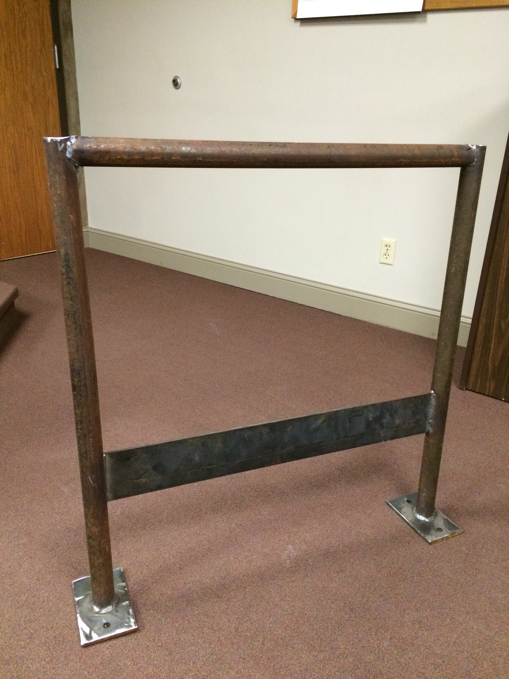

Note: Rack is about 35 inches tall and 30 inches’ wide

