Monthly Board Meeting Notes
December 15th, 2022
Beaverhead Trails Coalition
BTC board members present: Dan Downey, President; Ed Mooney, Vice-President; Joyce Connors, Treasurer; Celine Beaucamp-Stout
BTC guests present: Larry Skiles, Craig Simonsen, Ken Scalzone
BTC Executive Director present: None present

Prior to meeting Ed’s suggested Agenda:
- Approve minutes
- Treasurer report
- Pronghorn Trail Run
- Early Childhood Coalition hikes
- Other action items
- Committee Report; add In-Town Trails
- Others
- Next Meeting

1. Approve Meeting Minutes
- 10/17/22 – Monthly meeting minutes; Ed motions and Celine seconds with all in favor
- 7/20/22 – BOD meeting minutes; Joyce motions and Ed seconds with all in favor
- 5/05/22 – BOD meeting minutes; Ed motions and Dan D. seconds with all in favor
- 7/20/22 (6/06/22) – BOD meeting minutes; wrong date listed; tabled until corrected

2. Treasurer Report
- See following report for numbers
- Joyce spent many hours accounting for all the Giving Tuesday donations, especially what amount from what source. Totals for each source include checks $790, website $915, and Facebook $820 (which is outstanding until received).
- Two more bench sponsorships ($1000 per bench) were received in December.
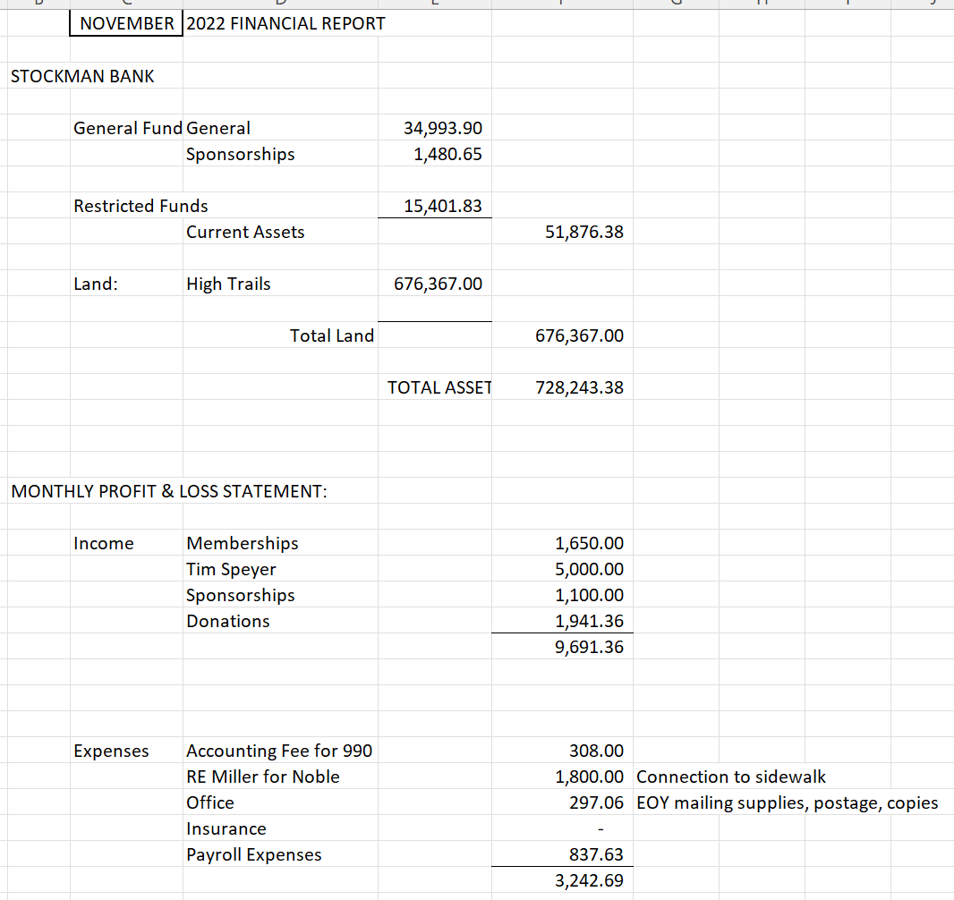

3. Pronghorn Pursuit Trail Run 2023
- In 2022, the event made _____ with a total of $882 in expenses.
- Bre’s hours: 13 hours totaling $260
- BTC did not participate much in the organization, therefore Joyce motions to keep $100 for BTC and give the rest to the cross-country team. Ed seconds; all in favor.
- For 2023, Betty Iverson wants to take the lead of the organization. Joyce motions to appoint Betty the lead for the event, with herself (Joyce) as the BTC representative. Ed seconds; all in favor and motion carries.
- The trail run will be on every agenda from now on so we can discuss action plan. The date of the event was briefly discussed, and it will not be changed because it is according to the high school cross-country team’s schedule. Efforts in advertising need to be greatly improved.
4. Early Childhood Coalition Hikes
- The topic was tabled until the next meeting.

5. Other Action Items
- Normal Street Bridge
  - Ed motions to approve the Feasibility Study by WET for $1000 (estimated by WET). Joyce seconds; all in favor; motion carries. Dan will sign it and send it back to Megan Terry with WET.
- Benches Memorial
  - We now have 4 benches in a queue to install. Dan motions to put the program on hold until we are caught up with installation. Joyce seconds; all in favor; motion carries.
- Action items
  - Send an email to Michael Mhoon and the Burke’s to let them know we will start planning soon.
  - If we send or distribute envelopes, we need to add “temporarily on hold”.
  - Add “temporarily on hold” to the website regarding bench purchases.
  - Ed motions to not accept any bench locations which are not accessible by motorized vehicle. Joyce seconds; all in favor; motion carries.

6. Grants
- Steele Reese – Kathleen and Joyce are getting ready to submit a letter of intent (for as soon as it opens in January). We will be submitting for the High Trails fence.
- Great Harvest – Joyce, Ed, and Kathleen worked on it, and it is ready to submit. The due date is December 23rd. The proposal will be for a connector trail between the Noble Ave. trail and the new Beaver Pride Trail.
- United Way – Not posted yet.
  - The first proposal would apply for a feasibility study for High Trails and West Trailhead. Ed motions; Joyce seconds; all in favor; motion carries.
  - The second proposal would be for the building of Normal Street Bridge. Celine motions; Ed seconds; all in favor; motion carries.
- Hydroflask – Grant for 96 bottles for upcoming Pronghorn Pursuit Trail Run – sent in by Kathleen
- Sloan Foundation – Normal Street Bridge; Ed will talk to the family to see if they are interested.
- Murdock – Joyce will investigate it.
- Ken Scalzone – Ken is from BWSWMT (Bike Walk Southwest Montana). The group wants to build one mile of trail at Chris Kraft Park. The trail kind of already exists but needs improvements. These would include adding a liner and roadbed. It’s estimated to be $16,000 to $28,000. We referred him to grant ideas and the county. We will keep Ken’s project in mind and BTC might be interested to partner in the future.

7. Committee Reports
- High Trails
  - Feasibility study for the West Trailhead is ongoing by WET.
  - Connection to BLM; we would like to build a fence this season; DNRC may potentially build a trail next season.
  - BLM knows we will put a trail to their land soon. We might need to remind them that people might start pioneering trails if we don’t provide them with guidance (provide with rocks?)
- In-Town
  - Met on 11/10/2022
  - Hwy Intersection: Dan has not received a response and will keep asking about what the plan is.
  - Reeder-Chapman-UMW
    - Noble Street Bridge Feasibility Study
    - Chapman crossing: Ed is talking to the mayor to see what is happening.
    - Park Street – Upcoming work on the section before Cornell Park. Completed work to include a 10-foot bike land, signage, and rumble strips. It’s possible that we will need to do a feasibility study and grant writing to help the city and county.

8. Others
- Box has past board members listed as users. Our membership only allows 10 members so Craig S. will take out Pete W. and Pat C. and add Alan W. and Bre.
- Craig S. has not received a membership email for two years and is wondering why. Others have not received a receipt, or the receipt has errors. This will need to be addressed as membership is very important to the organization.

9. Next Meeting
- Annual meeting to be held on January 26th. The meeting needs to be advertised at least 2 weeks in advance per our bylaws. The meeting needs to be advertised at least 2 weeks in advance per our bylaws.
  - Use a paid advertisement in the Tribune.
  - Also send to the Dillonite Daily and post as an event on our Facebook page/website.
  - The event is to include the Annual Meeting with Agenda and Election of board members/officers.
- Followed by a Board of Directors meeting – only for the seven board members and will include election of officers and BOD business.

